# 华为综合实验1：web配置AC+AP综合实验

登录AC

用户名：admin

密码： admin@huawei.com

注意事项：在核心3层交换机上开启DHCP功能，并配置DHCP地址池，DHCP选择接口模式

1.首先设置AC接口的vlan及中继链路

2.创建vlanif100的IP地址

3.配置DHCP

4.配置AC

https://192.168.10.10/

添加2个AP的MAC地址

5.在配置----》快速配置----》AP，创建AP组，并配置SSID,并添加

AP的MAC地址

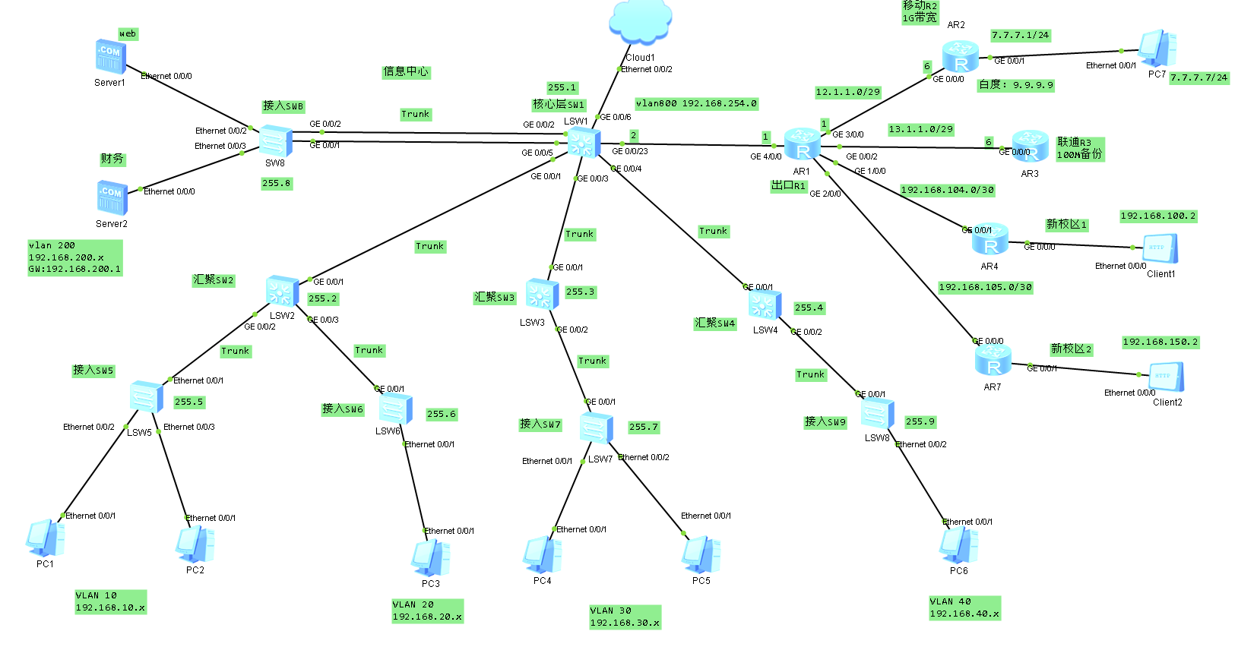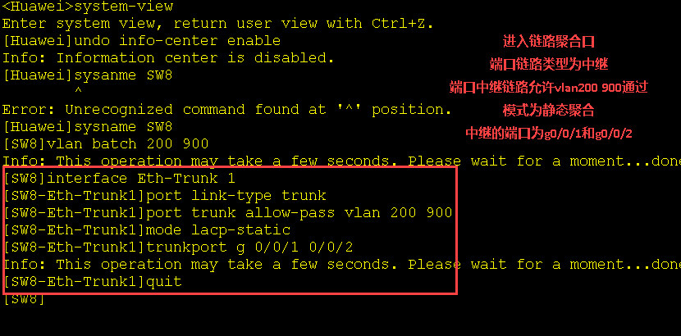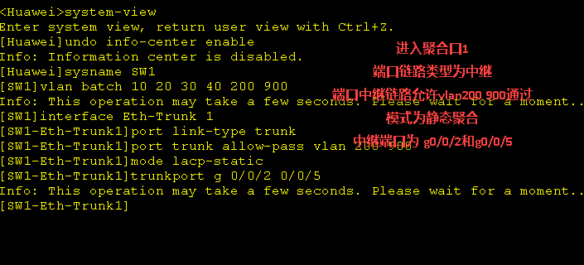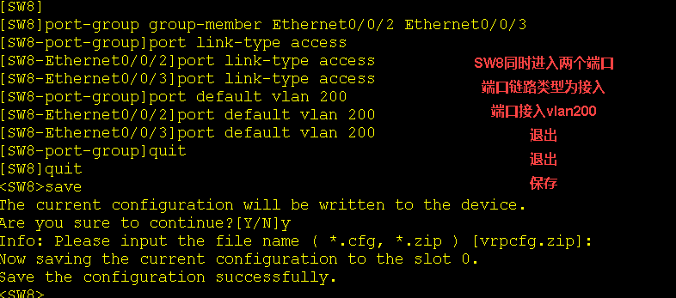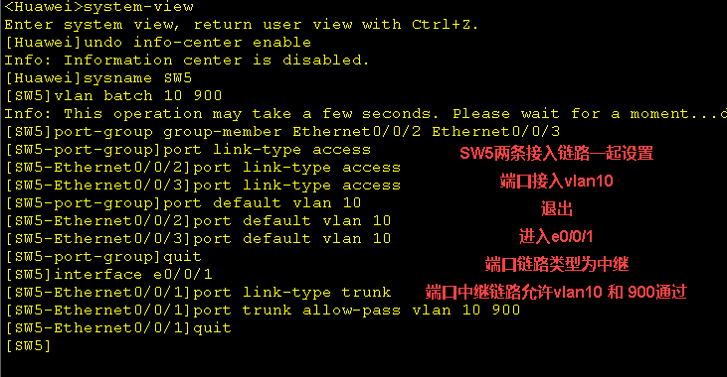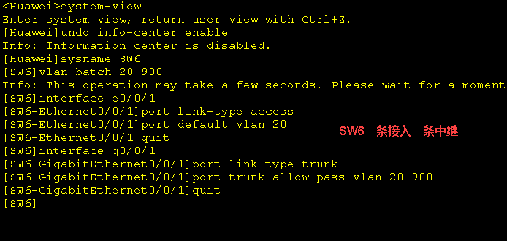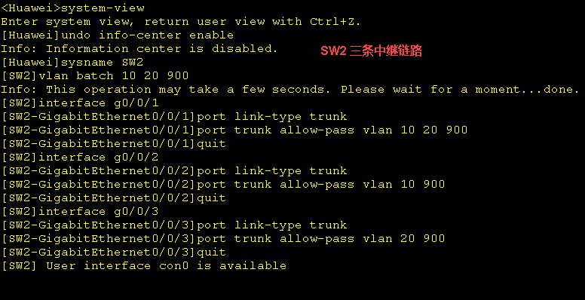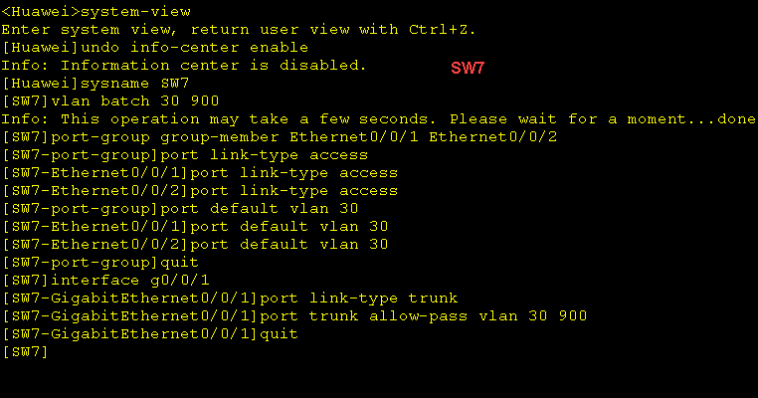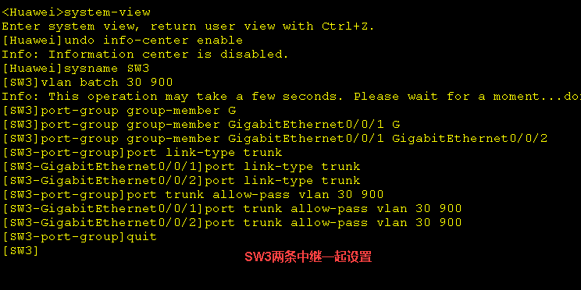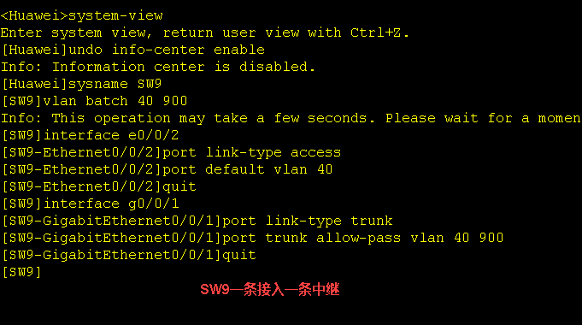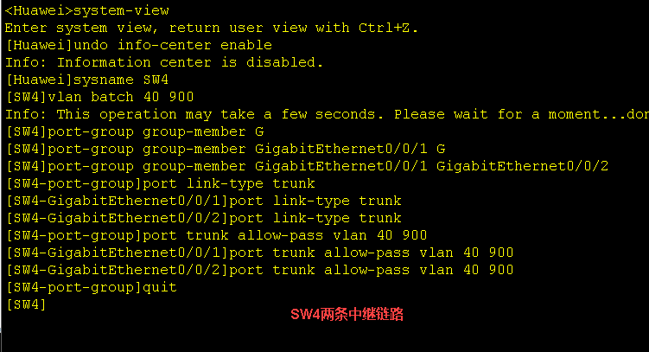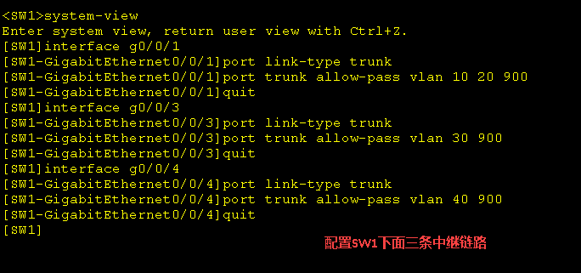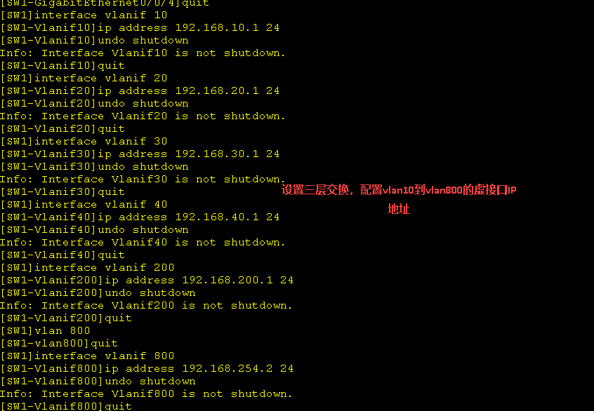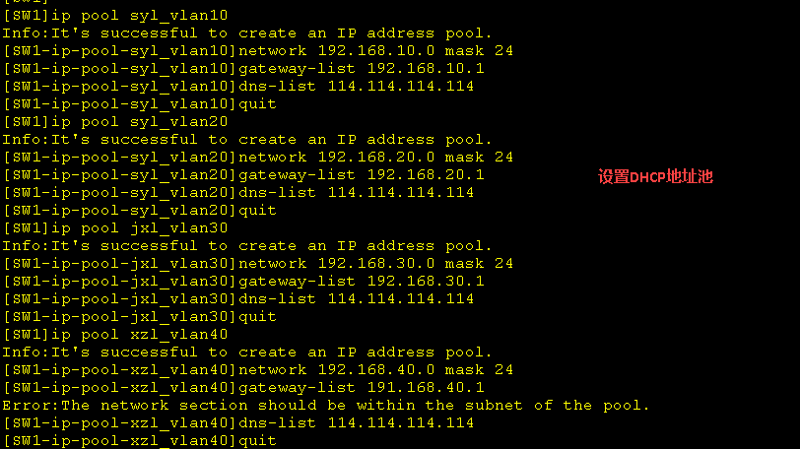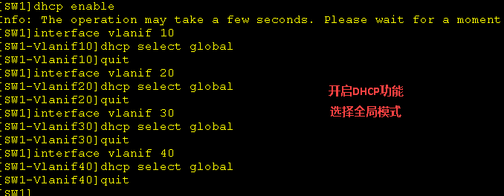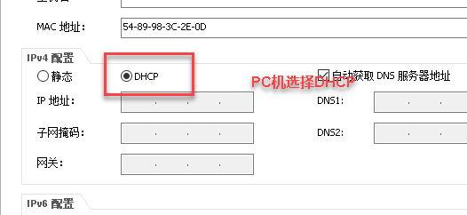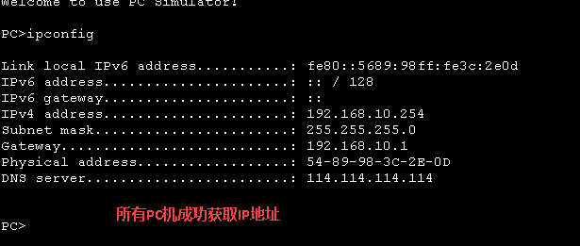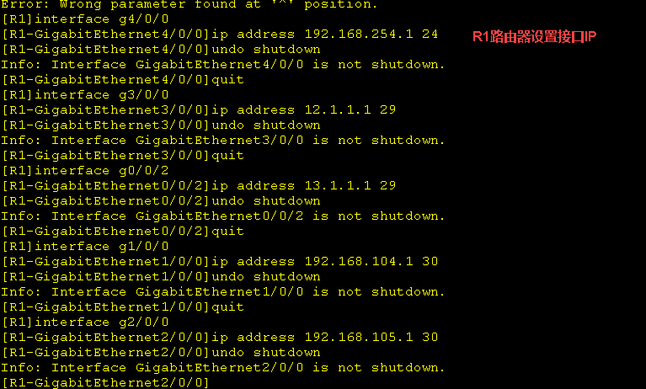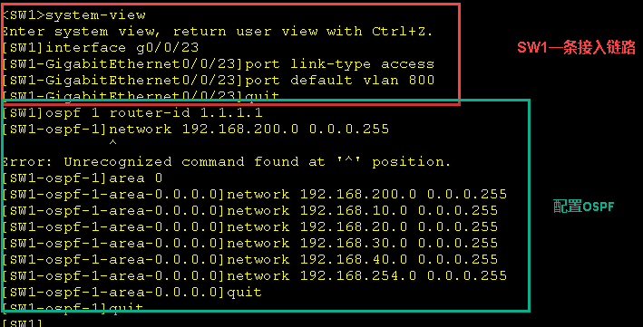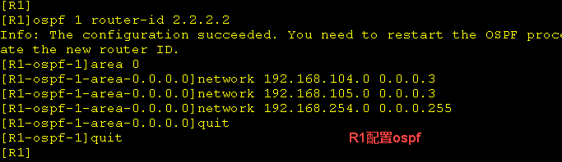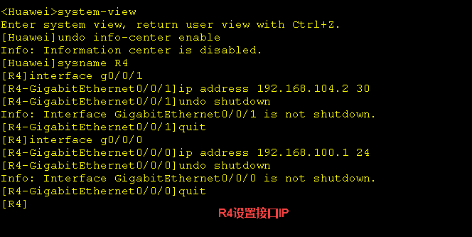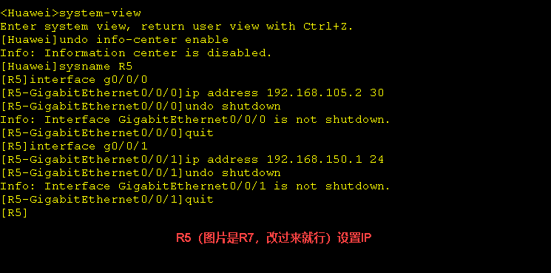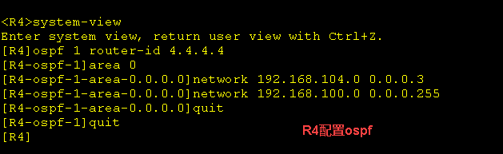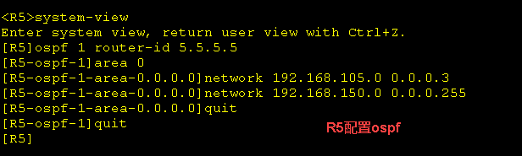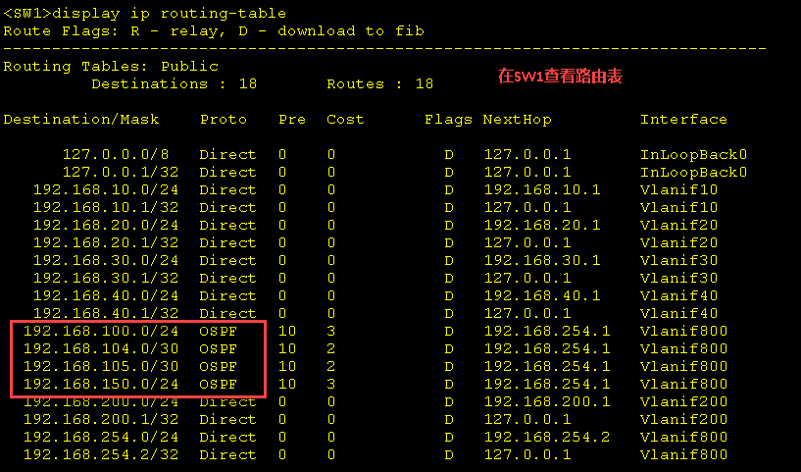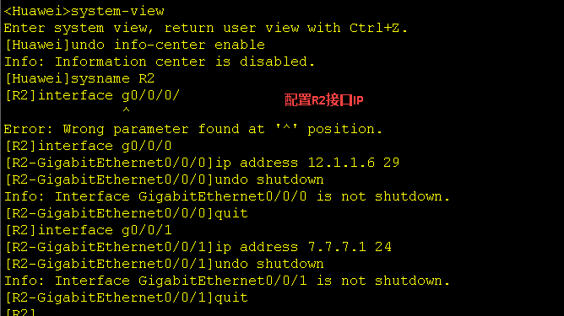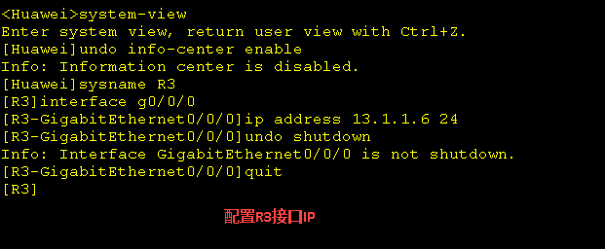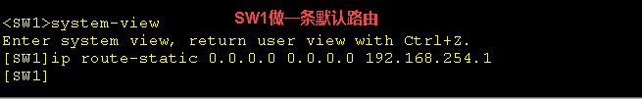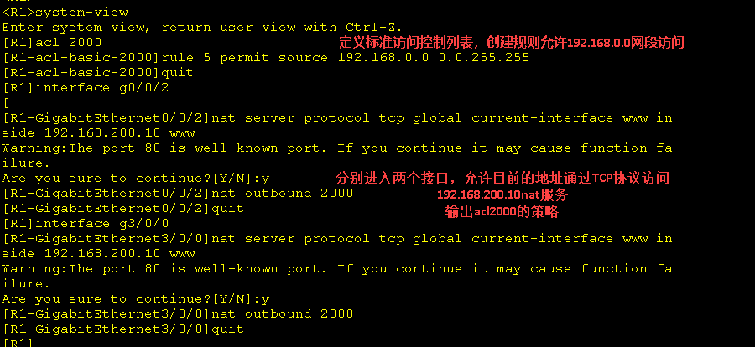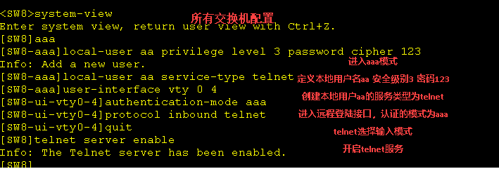

SW1-SW9:

system-view

aaa

local-user aa privilege level 3 password cipher 123

local-user aa service-type telnet

user-interface vty 0 4

authentication-mode aaa

protocol inbound telnet

quit

telnet server enable

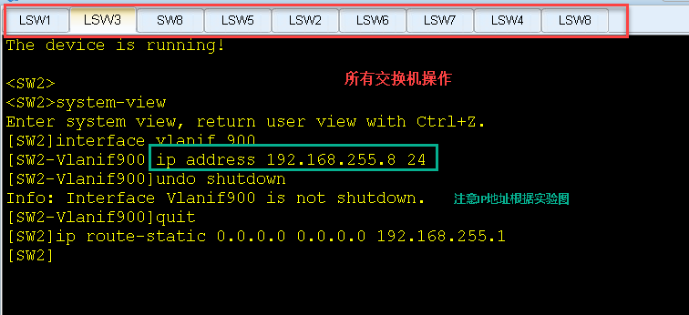

SW8:

system-view

interface vlanif 900

ip address 192.168.255.8 24

undo shutdown

quit

ip route-static 0.0.0.0 0.0.0.0 192.168.255.1

SW2:

system-view

interface vlanif 900

ip address 192.168.255.2 24

undo shutdown

quit

ip route-static 0.0.0.0 0.0.0.0 192.168.255.1

SW3:

system-view

interface vlanif 900

ip address 192.168.255.3 24

undo shutdown

quit

ip route-static 0.0.0.0 0.0.0.0 192.168.255.1

SW1:

system-view

interface vlanif 900

ip address 192.168.255.1 24

undo shutdown

quit

SW4:

system-view

interface vlanif 900

ip address 192.168.255.4 24

undo shutdown

quit

ip route-static 0.0.0.0 0.0.0.0 192.168.255.1

SW5:

system-view

interface vlanif 900

ip address 192.168.255.5 24

undo shutdown

quit

ip route-static 0.0.0.0 0.0.0.0 192.168.255.1

SW6:

system-view

interface vlanif 900

ip address 192.168.255.6 24

undo shutdown

quit

ip route-static 0.0.0.0 0.0.0.0 192.168.255.1

SW7:

system-view

interface vlanif 900

ip address 192.168.255.7 24

undo shutdown

quit

ip route-static 0.0.0.0 0.0.0.0 192.168.255.1

SW9:

system-view

interface vlanif 900

ip address 192.168.255.9 24

undo shutdown

quit

ip route-static 0.0.0.0 0.0.0.0 192.168.255.1

